**Course Title**

Design-on-Simulation Technology for Advanced Packaging Reliability Life Prediction

***Course Instructor and Affiliation:***

Prof. K. N. Chiang, PME of National Tsing Hua University, Taiwan

**Course Objective and Outline:**

The electronic packaging (EP) community has widely used Design-on-Simulation (DoS) technology for designing a new packaging structure. Still, it has encountered some challenges in ensuring a trustable simulation result. AI/machine learning approaches can be combined with DoS to solve this uncertainty. This course will use wafer-level packaging (WLP) to illustrate the solution methodology and procedure, including the FE model, mechanics theories, controlled mesh size validation, large database generation, and AI training performance of different machine learning algorithms. This talk will also describe how to combine AI and finite element simulation to estimate the reliability life of wafer-level packaging and obtain the best structure combination of each packaging component. This course will cover the following topics: (1) Finite element simulation, (2) 2D/3D model, (3) Material constitutive equations, (4) Mesh size control concept, (5) Simulation theory/materials/model validation procedure, (6) Solder joint reliability life cycle prediction empirical equations, (7) AI-Assisted DoS.

**Who Should Attend:**

This course aims to provide students and engineers with a comprehensive understanding of how to properly combine mechanics theories, constitution equations of material, finite-element modelling, and reliability life prediction empirical equations to estimate the reliability life cycle of area array type advanced packaging. Attendees are encouraged to bring topics and technical issues from their past, present, and future job functions for group discussions.

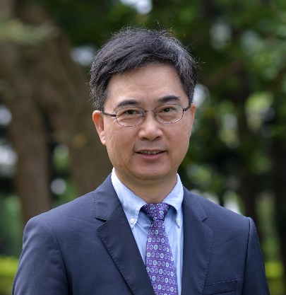

**Instructor Biography:**

Professor K. N. Chiang received his PhD from the Georgia Institute of Technology, USA. He is the Chair Professor at the National Tsing Hua University in Hsinchu, Taiwan. After graduating from Georgia Tech, he worked four years as a senior researcher at MSC/NASTRAN, a world-famous finite element system. From 2010 to 2013, he served as General Director of the National High-Performance Computing Center, which is the National Strategic Research Center of Taiwan. He has received outstanding research awards from the Ministry of Science and Technology of Taiwan three times and has published more than 450 technical papers in international journals and conference proceedings. He has been granted more than 50 invention patents. Among the major awards Professor Chiang received are the Excellence in Mechanics Award from ASME (2022) and the Outstanding Sustained Technical Contribution Award (2020) from IEEE-EPS. Currently, he is Editor-in-Chief of the Journal of Mechanics (SCI), Academic Editor of Materials (SCI), and Associate Editor of the Journal of Electronic Packaging (SCI). He is an IEEE, ASME, STAM, and IMAPS Fellow. And an academician of the International Academy of Engineering (IAE).

He has made significant achievements in simulation-based science and technology. He successfully combined simulation design with artificial intelligence technology and applied it effectively to semiconductor-related designs. His technology has greatly reduced product development time and development costs. He has worked with many major electronic packaging, semiconductor and LED companies such as ACET, TSMC, MediaTek, UMC, EPISTAR, VIA, Powertech Technology, etc.