**Course Title**

Automotive Electronics Reliability – Challenges and Opportunities

***Course Instructor and Affiliation:***

Pradeep Lall

MacFarlane Endowed Distinguished Professor, Alumni Professor and Director

Auburn University

USA

**Course Objective and Outline:**

The modern car has increased semiconductor content and dollar value. Semiconductors enable the majority of innovations in automotive. The increased emphasis on autonomous driving and the electrification of vehicles has resulted in enormous changes for semiconductors and packaging. The design, materials, and reliability strategies for automotive electronics will be presented. Electronics are increasingly being used in automotive platforms for various mission-critical and safety-critical activities, such as guidance, navigation, control, charging, sensing, and operator interaction. Over the last two decades, automotive platforms have expanded to incorporate hybrid and fully-electric vehicles. Much of the electronics is located under the car’s hood or in the trunk, where temperatures and vibration levels are far higher than in consumer office applications. During the vehicle’s use-life, electronics in the automotive underhood may be exposed to sustained high temperatures of 125-150°C for extended periods of time. The automotive electronics council (AEC) has graded electronics for automotive purposes into four categories: grade-0, grade-1, grade-2, and grade-3. Grade-0 components have the most demanding criteria of the four grade categories, with predicted power temperature cycling ranging from -40°C to +150°C for 1000 cycles and ambient temperature cycling ranging from -55°C to +150°C for 2000 cycles. Furthermore, the grade-0 components are expected to be capable of sustaining high-temperature storage for 1000 hours at 175°C. With the introduction of new packaging architectures, packaging applications have continued to evolve, allowing for powerful computing on mobile automobile platforms. New materials and integration technologies have also emerged, allowing for tighter integration of electronics sensing and processing into the structural characteristics of the vehicle. The automobile platform faces a series of constraints particular to the real-time context for enabling sophisticated functionality.

Specifically, the course will encompass the following topics:

1. Role of electronics on the automotive platform
2. Automotive environments
3. Zero-Defects
4. Second-Level Solder Interconnect Design Considerations
5. Copper Wirebond Interconnects
6. Advanced Packaging Interfaces
7. Vibration Effects
8. Sustained High Temperature and Wide Thermal Extremes
9. Corrosion Propensity
10. Accelerated Testing

**Who Should Attend:**

The goal of the course is to provide the students a comprehensive understanding of the materials and reliability consideration in the design of electronics for operation in the automotive platform. The course is intended to have an intermediate degree of difficulty to serve as an introduction for engineers and managers looking to design electronics for operation in the automotive underhood.

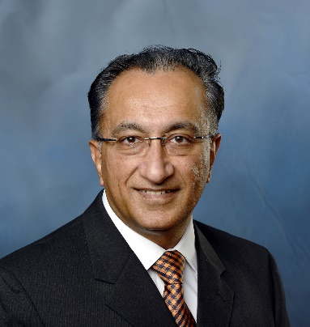

***Pradeep Lall, MacFarlane Endowed Distinguished Professor, Alumni Professor and Director, Auburn University***

**Instructor Biography:**

Pradeep Lall is the MacFarlane Endowed Distinguished Professor and Alumni Professor with the Department of Mechanical Engineering. He is the Director of the NSF-CAVE3 Electronics Research Center at Auburn University. He holds Joint Courtesy Appointments in the Department of Electrical and Computer Engineering and the Department of Finance. He is a member of the technical council and academic co-lead of automotive TWG and asset monitoring TWG of NextFlex Manufacturing Institute. He is the author and co-author of 2-books, 15 book chapters, and over 900 journal and conference papers in the field of electronics reliability, manufacturing, safety, test, energy efficiency, and survivability. Dr. Lall is a fellow of the ASME, a fellow of the IEEE, a Fellow of NextFlex Manufacturing Institute, and a Fellow of the Alabama Academy of Science. He is a recipient of the SEMI Flexi R&D Achievements Award for landmark contributions to Additive Printed Electronics, ASME Avram Bar-Cohen Memorial Medal, IEEE Biedenbach Outstanding Engineering Educator Award, Auburn University Research Advisory Board’s Advancement of Research and Scholarship Achievement Award, IEEE Sustained Outstanding Technical Contributions Award, NSF-IUCRC Association’s Alex Schwarzkopf Award, Alabama Academy of Science Wright A, Gardner Award, IEEE Exceptional Technical Achievement Award, ASME-EPPD Applied Mechanics Award, SMTA’s Member of Technical Distinction Award, Auburn University’s Creative Research and Scholarship Award, SEC Faculty Achievement Award, Samuel Ginn College of Engineering Senior Faculty Research Award, Three-Motorola Outstanding Innovation Awards, Five-Motorola Engineering Awards, and over Forty Best-Paper Awards at national and international conferences. Dr. Lall is the founding faculty advisor for the SMTA student chapter at Auburn University and a member of the editorial advisory board for SMTA Journal.